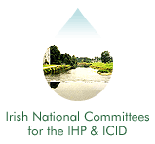
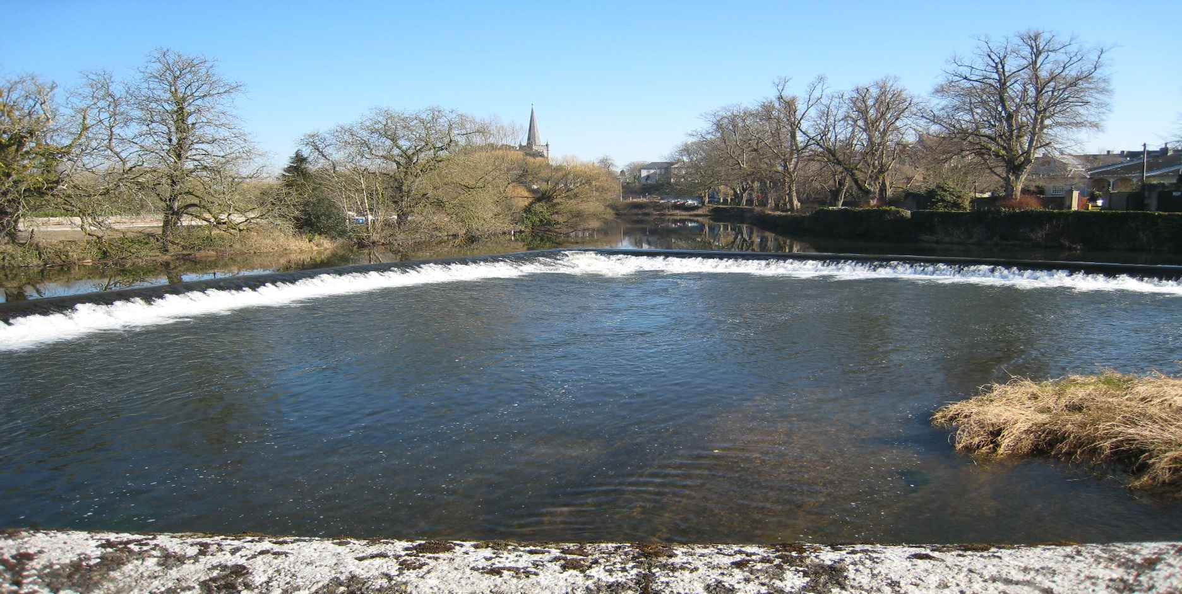
Irish National Hydrology
Conference 2020

First Announcement
Call for Papers & Posters

Tuesday, 17th November 2020

Hodson Bay Hotel

Athlone, Co. Roscommon

Introduction
The National Committees of the IHP/ICID invite you to Athlone for the 21st National Hydrology Conference to be held on Tuesday 17th November 2020 at the Hodson Bay Hotel. This event is Ireland's leading Conference devoted to Hydrology providing a unique forum for attendees to share policy developments, research results, and practical solutions to engineering hydrology issues.

Conference Theme ..
In hydrology, practitioners apply scientific knowledge and mathematical principles to solve practical problems relating to water, floods and droughts, erosion and sediment transport. The application of hydrological techniques to planning and design of water related projects has always been a primary concern to hydrologists. In view of the increasingly complex scope of water related projects, need to have a sound knowledge of the classical as well as the most modern analytical techniques applied in this field of physical hydrology or engineering hydrology is indispensable.

We would like to invite strong, technical, papers/posters with applications of physical hydrology/engineering hydrology, systems analysis, hydrological processes, hydrological modelling & flood forecasting, storm drainage, drought, climate change, tracing COVID-19 in rivers, and current developments in hydrology. These topics can range from case studies, to practical applications of hydrological practices, to research focused projects.

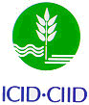
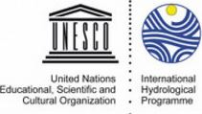

Who are the expected attendees?
- Local Authority Engineers and Planners
- Engineering Consultants, Researchers, Hydrologists, Environmental Engineers and Scientists
- Policy makers from all relevant fields
- Professionals involved with the implementation of the various EU water management Directives.

Conference Format .
The programme will consist of oral presentation of papers with discussion, and a poster / display session. Participants are invited to contribute through posters and oral presentations. It is expected that this year’s conference will be also broadcast online.

Call for Papers . .
Participants willing to contribute to the Conference through the presentation of a paper should submit a short abstract (maximum 600 words). The abstracts should be sent by e-mail to the Conference Secretariat by Friday, 14th August. The organising committee will review the abstracts and inform the successful authors by Thursday, 30th August.

Call for Posters ..
Participants willing to contribute through the provision of a poster display should submit a short summary (maximum 300 words) of the project or topic. The deadlines for submissions and the review and acceptance format and dates are as per the call for papers above.

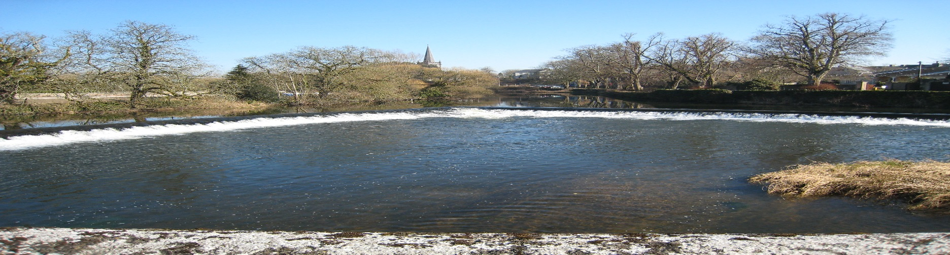
Irish National Hydrology
Conference 2020

Conference Booking & Costs .
The cost of attendance at the Conference is which includes refreshments and lunch will be decided in the notifications to follow.

Conference Programme ..
The Programme for the Conference will be confirmed nearer the date. It is currently envisaged that the Conference will run from 10 a.m. to 4:30 p.m.

Registration / Further Information .
To register to attend the conference or to request further information, please complete the registration form and return to:

Contact: IHP/ICID Secretariat,
Office of Public Works, Head Office,
Trim,
Co. Meath, Ireland.
Tel: 046 942 6738
E-mail: nhc@opw.ie

Organisers
International Hydrological Programme (IHP) .
The UNESCO international scientific co-operative programme in hydrology and water resources, the IHP, was established to act as a catalyst to promote co-operation and research in the management of water resources, an issue which had been identified as a significant limiting factor for harmonious development in many regions and countries of the world.
International Commission on Irrigation and Drainage (ICID) ..
The mission of the ICID is to stimulate and promote the development of the management of water and land resources for irrigation, drainage, flood control and river training applications, including research and development and capacity building.

Registration Form
Name:
Job Title:
Organisation:
Address:
Tel: Fax:
E-mail:
I would like to present a paper
I would like to present a poster

Title or explanation of Paper/Poster
I wish to receive further information

