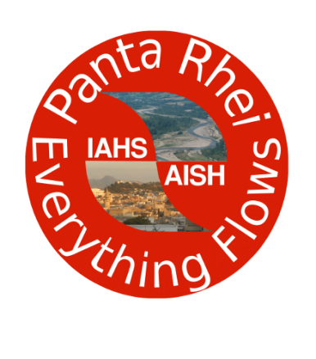 | Panta Rhei – Everything Flows  Change in Hydrology and Society  IAHS Scientific Decade 2013-2022  www.iahs.info/pantarhei

Panta Rhei Working Group: Changes in Flood Risk
Report of the activity of the working group in 2015
Three working group (WG) meetings were organised, one at EGU in April 2015 in Vienna, one at the ECCA Conference in May 2015 in Copenhagen, and one at the AGU in December 2015 in San Francisco. During these meetings the concept for our joint paper on paired flood event case studies was developed. The writing of the individual case-studies started in November 2015.
(Co-)Organization of Workshop/Sessions:
Co-organisation of EGU PICO session “HS2.4.4 Flood changes: understanding the drivers of hazard and risk” 12–17 Apr 2015, Vienna, Austria
Organisation of Session “Adaptation to changing flood risk” at the European Climate Change Adaptation Conference (ECCA) 12-14 May 2015, Copenhagen, Denmark
Co-organisation of Session “Extreme hydrological events: deciphering changes in hazard and risk at different time-scales” at the conference “Our Common Future Under Climate Change”, 7-10 JULY 2015, Paris, France
Co-organisation of EGU session “HS2.4.4 Flood dynamics: processes, controls, consequences”, 17–22 April 2016 Vienna Austria
Poster presentation:
Heidi Kreibich and the IAHS Panta Rhei Working group "Changes in Flood Risk" Team (2016) “Drivers of flood damage on event level” in EGU Session HS2.4.4. Attendance Tue, 19 Apr, 17:30–19:00
Papers:
Kreibich et al. (in preparation) Drivers of flood damage – results of paired flood event studies. For publication in the Panta Rhei special issue in HESS.
Kienzler, S., Pech, I., Kreibich, H., Müller, M., Thieken, A. H. (2015): After the extreme flood in 2002: changes in preparedness, response and recovery of flood-affected residents in Germany between 2005 and 2011. - NHESS, 15, 505-526.
Benefits of the Panta Rhei working group are the following:
- Opportunity for cross country comparison case-study on the dynamics and changes in flood risk
- Intensification of international co-operation between hydrologists, engineers and social scientists, also to explore opportunities for joint research projects and synthesis publications
- Large basis for organising topical sessions at important conferences
- More visibility for organised sessions and joint papers via the Panta Rhei web-site

